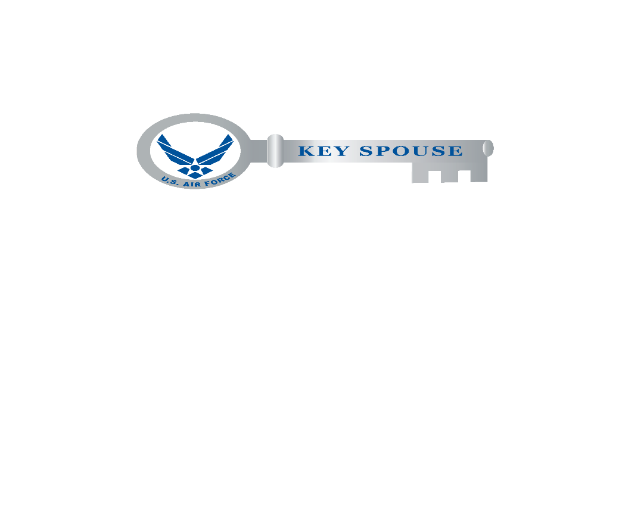
CC KSP Checklist…How am I Doing?
____ Do you understand what the KSP is and why it’s important for your unit to have KS & KSM? If no, please read the KS Guide found at: https://www.afpc.af.mil/Benefits-and-Entitlements/Key-Spouse-Program/
____ Have you explained your unit’s mission, vision, goals and what difficulties, struggles the members/families may have/face to all the KSP appointees? If no, please have a meeting with them and recommend discussing the Statement of Understanding (SOU) found in the KS guide.
____ Do you know what your units roles and responsibilities are in regards to the KSP? If no, please read the KSP guide and ask the Airman & Family Readiness Center (A&FRC) for assistance.
____ Has your unit leadership meet with all the KS & KSM? If no, we recommend having a meeting so everyone can meet and explain what they do (to include, First Sergeant, Chief/Superintendent). KS & KSM need to feel a part of the team to be successful and feel included.
____ Do you know who the KS, KSM, and other spouses are in your unit? If no, have your unit maintain a unit roster & meet them.
____ Is the KS & KSM being invited/attending the Commander’s Calls, Resiliency Days, True North events, & any other unit activities? If no, ensure you are including them so they feel valued and appreciated. If they are not known, the KSP cannot be effective.
____ Does your unit have documentation for all KS and KSM? If no, read the KSP Guide and ensure you maintain apt letter, volunteer form, and proof of KS training for each appointee. Additionally, recommend documenting that all have acknowledge their responsibilities for protecting OPSEC, PII, Privacy Act of 1974, and signed the Statement of Consent form. Contact the A&FRC for more assistance.
____ Do you feel your unit has the resources readily available to assist the unit’s KS and KSM if they come to you for aid? If no, have you read the resources section of the KS Guide, suggested downloading the Team Minot App, and talked with your A&FRC? If yes, please provide feedback to the A&FRC because it needs to be addressed. Human compassion and the ability to be able to share/relate concerns, frustrations, etc and even seek aid/advice is at the forefront of what the KSP stands for.
____ Is your unit KS utilizing the communication log, volunteer tracking log, unit roster, key spouse checklist, privacy act sheet accordingly? If no, please print them for the KS & KSM as their role falls under an official position within the unit’s family readiness and supplies needed to accomplish those roles should be provided by the unit.
____ Do you feel the unit KS are appreciated? Has the unit recognized anyone in the KSP with a coin, letter of appreciation, submitted an award for Key Spouse of the Year (KSoY) or Volunteer Excellence Award? If no, advocate to the KSM to provide assistance.
____ Do you know how KSP funding works? You may utilize appropriated funds for KSP items with little value: pens, pencils, magnets, key chains, plastic tags, wall calendars, mugs, buttons, notepads and must contain information promoting the KSP awareness and services (such as contact info, services provided, etc). Additionally business cards and name tags can be created as long as it utilizes government supplies (cardstock, printers, etc). For coins, coordinate with the A&FRC and they should only be utilized as recognition for volunteer services. There is no authority to utilize appropriated funds for T-shirts. Any “gifts” under $50 should be strongly scrutinized when looking to recognize/award a KS. See NAF & Budget AFIs, as well as SAF/GC Memo, Authority to use APF to buy KSP Items, 22 May 2017
____ Do you feel the unit’s KSP is successful? If no, have you reviewed the KSP “Tips and Success Stories” in the KSM guide, as well as reached out to other CC’s, KS, KSM, and the A&FRC for assistance. If yes, please provide feedback to the A&FRC.

